China-Japan Workshop on Soybean Yield Physiology

(WSYP’2013)
August 26-29, 2013, Harbin, China

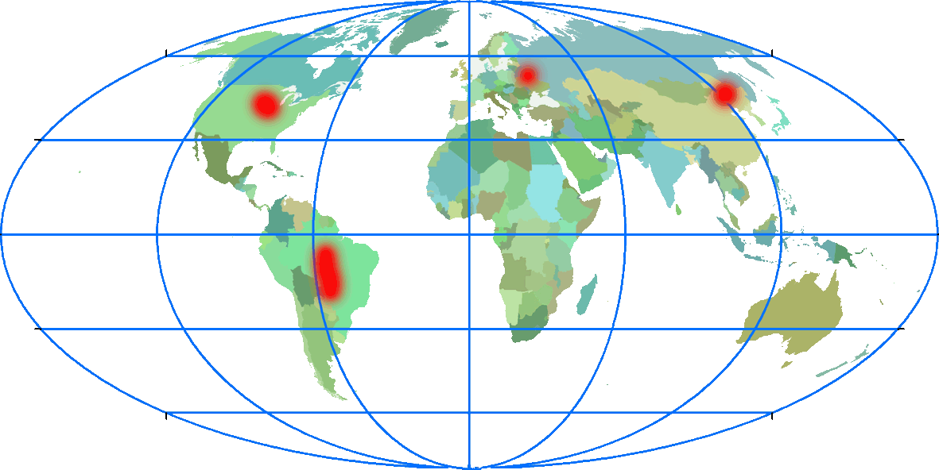

Organized by
Northeast Institute of Geography and Agroecology, Chinese Academy of Sciences
Key Laboratory of Mollisols Agroecology, Chinese Academy of Sciences
Sponsored by
Key Laboratory of Soybean Molecular Breeding, Chinese Academy of Sciences
Institute of Soil Tillage and Cultivation, Heilongjiang Academy of Agricultural Sciences
Co-sponsored by
Soybean Specialty Committee, Crop Science Society of China
Heilongjiang Society of Mollisols Conservation and Utilization

Local Organizing Committee
Dr Xing-yuan He
Dr Xiao-bing Liu
Mr Zhong-qiang Liu
Dr Yong-cai Lai
Dr. Yui-yu Sui
Dr Chong-sheng Gao
Mr Xue-song Wang
Dr. Fan-jiang Kong
Dr. Xing-yi Zhang
Mr Hong-jia Liu
Mr Ju-dong Liu
Mr Xiang-yue Li
Mr Wei-nong Li

Scientific Committee
Dr Tian-fu Han, China
Dr Xiao-bing Liu, China
Dr Kuniyuki Saitoh, Japan
Dr Shao-hui Zheng, Japan
Dr Tie-qing Huang, China
Dr Guang-hua Wang, China
Dr Bao-hui Liu, China
Dr Hai Nian, China
Dr Shu-ming Wang, China
Dr Wei-qun Man, China
Dr Zhen-ping Gong, China

Workshop Program for WSYP’2013

Aug 26 Arrival and registration
Aug 27 Academic presentation
Aug 28 Visiting Hai-lun Agroecological Experiment Station and Hai-lun Monitoring and Research Station of Water and Soil Conservation
Aug 29 Field tour and on-site production practice discussion

Contact: Dr. Chongsheng GAO
Tel.: +86-451-86602913
Email: csgao@neigaehrb.ac.cn

Mr. Hongjia LIU
Tel.: +86-451-86602927
Email: liuhj@neigaehrb.ac.cn

Mr. Judong LIU
Tel.: +86-451-86602774
Email: liujd@neigaehrb.ac.cn

Academic program on August 27, 2013
Opening ceremony
Time | Speaker |  | Contents | Moderated by
08:30-08:35 | Professor/Dr. Xing-yi Zhang, Head of Water and Soil Conservation Monitoring and Research Station, Northeast Institute of Geography and Agroecology, CAS |  | Guest introduction | Professor Xing-yi Zhang, Head of Water and Soil Conservation Monitoring and Research Station, Northeast Institute of Geography and Agroecology, CAS
08:35-08:40 | Professor/Dr. Xiao-bing Liu, Vice director-general of Northeast Institute of Geography and Agroecology, CAS |  | Welcoming speech
08:40-08:45 | Professor Chang-bin Zhang, Deputy director-general of Heilongjiang Department of Science and Technology |  | Addressing a speech
08:45-08:50 | Professor Yong-cai Lai, Director of Soil Tillage and Cultivation Institute of Heilongjiang Academy of Agricultural Sciences |  | Addressing a speech
08:50-08:55 | Professor/Dr Makie Kokubun, Touhoku University, Japan |  | Addressing a speech
Academic presentations
Time | Speakers | Title |  | Moderated by
09:00-09:20 | Professor/Dr. Tian-fu Han, Chinese Academy of Agricultural Sciences | Yield-related trait evolution of widely-planted soybean varieties in China |  | Professor/Dr. Guang-hua Wang, Deputy Chief of  Key Laboratory of Mollisols Agroecology,  Chinese Academy of Sciences
09:25-09:45 | Professor/Dr. Makie Kokubun, Tohoku University, Japan | Genetic and cultural improvement of soybean under excess/deficit soil moisture
09:50-10:10 | Professor/Dr. Guo-hua Hu, director of Crop Breeding Center of Heilongjiang General State Farms | Modern soybean production pattern and yield breakthrough in the state farms of China
10:15-10:35 | Professor/Dr. Kuniyuki Saitoh, Okayama University, Japan | Morphological and physical traits of soybean related to lodging and their cultivar differences
10:40-11:00 | Professor/Dr. Xiao-bing Liu, Vice Director-general of Northeast Institute of Geography and Agroecology, CAS | Roles of solar radiation and plant hormones in soybean yield formation
11:05-11:25 | Dr. Shinji Shimada,  Director, Crop Production Systems Division, National Agricultural Research Center, NARO, Japan | Soybean production system on drained paddy fields in Japan
11:30-11:50 | Dr Michiel A Smit and Mr Armand Smit, Durban City Council Economic Development Cluster, South Africa | Adaptation of Edamame soybean in South Africa：Physiological constraints to overcome
12:00-13:00 | Lunch (second floor restaurant)
13:10-13:30 | Professor/Dr. Hai Nian, Southern China Agricultural University | Breeding and cropping system of soybean in South China |  | Professor/Dr. Wei-qun Man, Soybean Research Institute, Heilongjiang Academy of Agricultural Sciences
13:35-13:55 | Professor/Dr. Akihiro Isoda, Graduate School of Horticulture, Chiba University | High-yielding performance of soybeans in Northern Xinjiang
14:00-14:20 | Professor/Dr. Fu-ti Xie, Shenyang Agricultural University, China | Morphological and physiological traits of super-high-yielding soybean
14:25-14:45 | Dr. Katsunori Isobe, Associate Prof., Nihon University, Japan | Effect of different crop types on Arbuscular Mycorrhizal fungal colonization and subsequent soybean yields
14:50-15:10 | Dr. Shao-Hui Zheng, Associate Prof., Saga University, Japan | The role of nitrogen accumulation and redistribution on soybean seed yield
15:15-15:35 | Coffee break
15:35-15:55 | Professor/Dr. Wen-yu Yang, Vice president of Si-chuan Agricultural University, China | Application and theory of the corn-soybean strip intercropping system in Southwestern China |  | Professor/Dr. Fan-jiang Kong, Deputy Chief of  Key Laboratory of Soybean Molecular Breeding, Chinese Academy of Sciences
16:00-16:20 | Dr. Tomiya Maekawa,  Researcher, Crop Production Systems Division, National Agricultural Research Center, NARO, Japan | Effects of short water-logging on soybean N fixation

16:25-16:45 | Professor/Dr. Shu-ming Wang, Director of Soybean Research Institute, Jilin Academy of Agricultural Sciences | High yielding physiology and root system traits in hybrid soybean
16:50-17:10 | Professor/Dr. Tatsuhiko Shiraiwa, Kyoto University, Japan | The effect of hot weather on soybean yield
17:15-17:35 | Professor/Dr. Dian-feng Zheng, Center director, Heilongjiang Bayi Agricultural University, China | How plant growth regulators influence soybean plant？
17:40-17:50 | Professor Xiao-bing Liu  Chairman of the workshop | Closing remarks
18:00-19:30 | Gala dinner |  | Professor/Dr.  Bao-hui Liu, assistant director Northeast Institute of Geography and Agroecology, CAS

